Data Analysis:

1. Data was provided of 3 dates – 1st to 3rd OCT’19.
2. Data was shared with following information

FacilityCode 1077615 non-null int64

FacilityName 1077615 non-null object

FTypeShort 1077615 non-null object

FtypeCat 1077615 non-null object

CityName 1077615 non-null object

VisitCode 1077615 non-null int64

OrderID 1077615 non-null object

PatCode 1077615 non-null int64

GENDER 1077615 non-null object

Age 1077615 non-null int64

ServiceCode 1077615 non-null int64

ServiceName 1077615 non-null object

ItemName 1077615 non-null object

Result 1010161 non-null object

AbnormalFlag 1077615 non-null object

mdate 1077615 non-null int64

dtypes: int64(6), object(10)

1. Data profiling already share with all (attaching same again for easy reference)
2. Date was data received

1 524366

3 519641

2 33608

1. 0.4% overall data found missing
2. Data found blank mainly in Result Column
3. Count of Distinct values of Facility code and name not matching

Count of distinct facilitycode: 2498

Count of distinct facilityname: 2476

1. Distict wise count of test performed

Nashik 72497

Pune 57412

Amravati 48629

Jalgaon 44943

Raigad 42684

Nagpur 42635

Kolhapur 42232

Yavatmal 41087

Chandrapur 37976

Thane 37576

Nanded 35299

Aurangabad 33580

Bhandara 33360

Wardha 31595

Ahmadnagar 31003

Solapur 30920

Satara 29498

Nandurbar 29350

Ratnagiri 28438

Latur 28109

Gadchiroli 27966

Gondia 27762

Sangli 27045

Beed 26793

Palghar 26042

Buldhana 22022

Jalna 21575

Sindhudurg 21221

Akola 21190

Dhule 19215

Parbhani 16312

Osmanabad 15933

Washim 13877

Hingoli 11604

Mumbai City 235

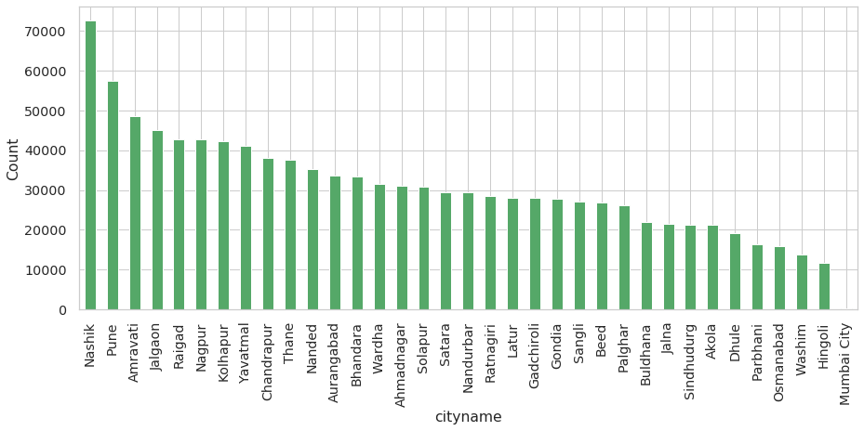

1. Analysis based on Gender
   1. Unique values found Gender

['M', 'F', 'O']

* 1. Count of transactions as per Gender

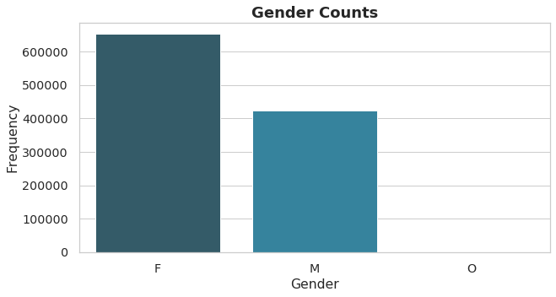

1. Based on Abnormal Flag
   1. Unique values found in Abnormal Flag

['N', 'L', 'H', 'I']

* 1. Count of transaction as per Abnormal Flag

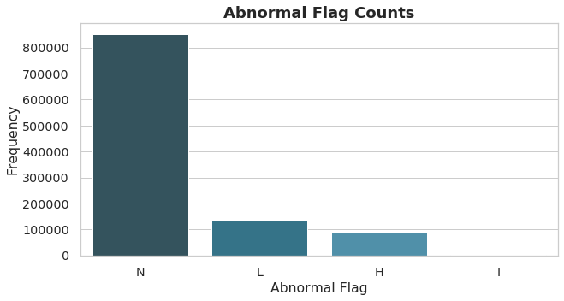

* 1. Gender wise Abnormal flag distribution in data

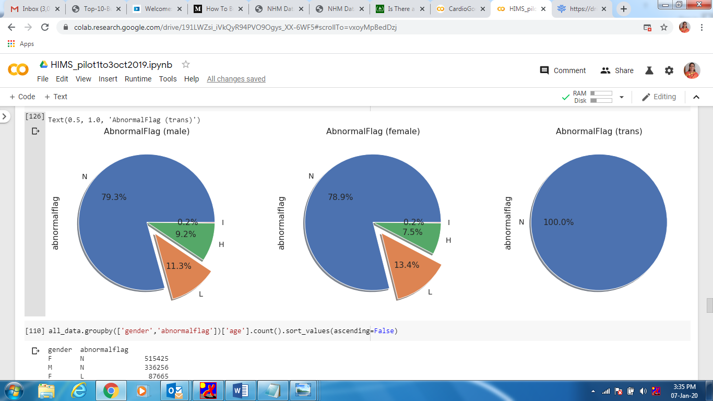

1. Analysis based on Age
   1. Count of transactions based on age slab

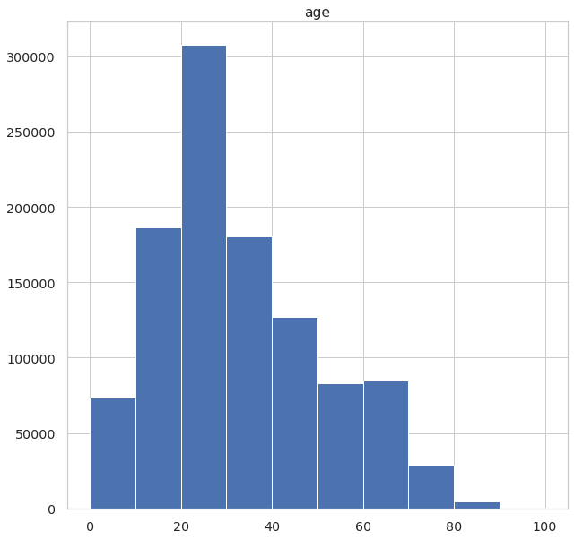

* In a given data 25% of Patient's Age is below 20
* In a given dat 50% of Patient 's Age is below 28
* Average Age in Given Data is 28 Years
* Mean of Age in Given Data is 32 Years(31.8 Years). Average age of Patient is 32 Years
* Minimum Age in given data is 0 Years
* Maximum Age in Given data is 100 Years